According to Wikipedia, Amazon has been referred to as "one of the most influential economic and cultural forces in the world", and the world's most valuable brand.



Here is your opportunity to get one of the most wanted and profitable lots on market!
- - Condition:
- 95% is new - Return refused or customer changed their mind
- 5% may have cosmetic defects or damaged packaging
- - Categories: Household items, Toys and baby products, Household appliances and many more fast selling, profitable items!

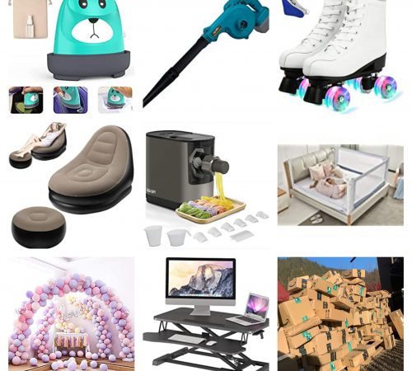
Lot 23 Amazon
Quantity: 5386 items
Retail recommended price: € 91.549
Our price: € 17600

Packing list 23

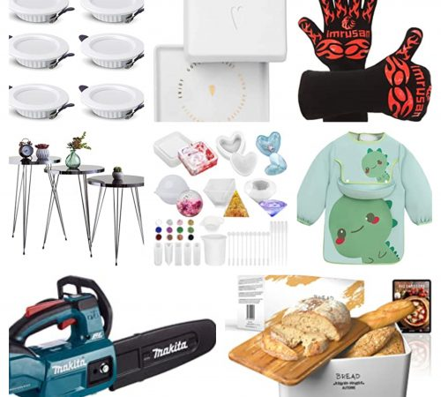
Lot 25 Amazon
Quantity: 3705 items
Retail recommended price: € 59.623
Our price: € 12700

Packing list 25


Lot 26 Amazon
Quantity: 3863 items
Retail recommended price: € 58.282
Our price: € 11990

Packing list 26

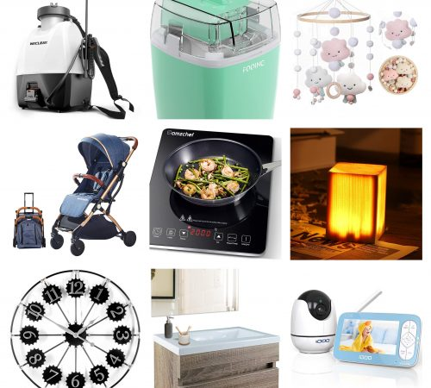
Lot 29 Amazon
Quantity: 2465 items
Retail recommended price: € 41.849
Our price: € 10500

Packing list 29

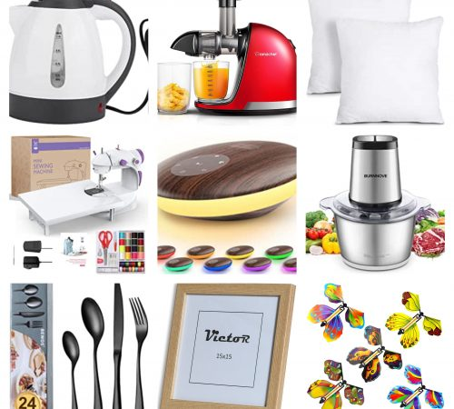
Lot 30 Amazon
Quantity: 2071 items
Retail recommended price: € 45.135
Our price: € 10900

Packing list 30


Lot 31 Amazon
Quantity: 4769 items
Retail recommended price: € 90.876
Our price: € 17300

Packing list 31

